

MYSORE SALES INTERNATIONAL LIMITED
(A Govt. of Karnataka Undertaking)
36, Cunningham Rd, Vasanth Nagar, Karnataka 560052

Short term Tender Notice Call-4
(https://kppp.karnataka.gov.in) INVITATION OF BIDS (VOLUME-2)

Appointment of Agency for implementing Enterprise Resource Planning (ERP) for MSIL

Contents
- About MSIL (Mysore Sales International Limited) 3
- About the Project 3
- Objectives of the project 3
- Brief Overview of services to be rendered 4
- Departments 4
  - Tours and travel 4
  - Paper 5
  - Consumer and Industrial Products Division 6
  - Pharma 7
  - Beverages 7
  - Chit Fund 8
- Verticals across Departments 9
- Project Detailed Scope 9
  - The detailed scope of work for the project 9
  - The scope of work for implementation 10
  - The overview of the implementation services 10
  - The Overview of the support Services 12
  - Skill augmentation 12
- ERP Deployment Strategy 12
  - Implementation activities 13
  - Documentation Phase 13
  - Deployment Phase 14
  - Testing and Acceptance Phase 15
  - Rollout Phase 16
  - User Acceptance and Go live Phase 17
- High-level functional requirements -Departments 18
  - Tours & Travel 18
  - Industrial Products Division 20
  - Paper Division 22
  - Beverage Division 23
- High level Functional Vertical Requirement:
25
  - Marketing, Sales & Distribution 25
  - Finance and Accounting 26
  - Inventory 27
  - Supply Chain Management 28
  - Assets Management 29
  - MIS 30
- Annexures to Functional Requirements
32

TERMS OF REFERENCE

About MSIL (Mysore Sales International Limited)
Mysore Sales International Ltd. (MSIL), a distinguished enterprise under the Government of Karnataka, has been a pivotal force in the marketing and distribution of a diverse range of products and services since its inception in 1966. Initially founded as a centralized marketing unit to fulfil the state's requirements, MSIL has evolved into a dynamic, multi-product, and multi-faceted organization, widely recognized as one of the leading public sector entities in India.
Over the years, MSIL has expanded its operations across various domains, catering to both governmental and commercial needs with efficiency and reliability. Its business portfolio includes key sectors such as paper products, tours and travel, beverages, industrial goods, pharmaceuticals, and financial services through its chit fund division. This diversified presence enables MSIL to make a significant contribution to the state's economic growth while maintaining high standards of service and product quality.
Guided by a commitment to excellence, transparency, and innovation, MSIL continues to adapt to changing market dynamics, leveraging technology and strategic partnerships to enhance its service offerings. With a strong reputation for integrity and customer satisfaction, MSIL remains a trusted name, serving businesses and consumers across Karnataka and beyond.

About the Project
MSIL is undertaking a strategic modernization initiative to meet the increasing demand for process automation throughout its operations. As part of this, the organization plans to implement a comprehensive ERP solution across all departments at its Head Office.
This digital transformation will utilize cutting-edge information technology to streamline business processes, enable internet-based accessibility, and extend system deployment to both the Head Office and branch locations. The solution aims to improve product management, enhance reporting capabilities, and optimize the overall flow of information.
Additionally, MSIL aims to integrate its main departmental activities through automated workflows and business process mapping. This will support informed decision-making by using a centralized electronic information database created through real-time system operation.
It is now proposed to avail the services of ERP on Software as a Service model.

Objectives of the project
- Modernization of Existing Systems & IT solutions
- Accelerated and Informed decision making
- Optimised demand & Supply monitoring

- Enhanced interdepartmental communications among Finance and HR teams
- Unified Integration of Departmental Core Functions
- Deployment of an electronic workflow system to improve internal administrative efficiency and transparency
- Digitization of Business Processes via ERP Implementation
- To improve productivity and responsiveness of employees and reduce cycle time through introduction of ERP solutions-based processes
- Continuous Operational Improvement with Strategic Information Support
- Comprehensive Process coverage
- Scalability for User base
- Robust Capabilities and Functional features
- System Integration
- Future expansion
- Strategic governance

Brief Overview of services to be rendered:
- The project shall be executed on a turnkey basis by a qualified agency, which will bear full responsibility for all components detailed in this RFP
- The selected agency must analyse MSIL’s requirements as outlined in the RFP and recommend a robust ERP solution that aligns with those needs.
- The agency will be responsible for the complete implementation of the proposed ERP system, along with post-deployment support services to ensure operational continuity.
- Based on MSIL’s specifications, the agency will size appropriate hardware and manage the installation and commissioning of the ERP system accordingly.
- The ERP system will be hosted on server infrastructure procured by MSIL specifically for the project.
- The agency must provide comprehensive operational support for a period of three years following the system’s go-live, ensuring stability and performance.

Departments:

Tours and travel
Considering the steep surge in tourism and hospitality industry, MSIL started Tours and Travels division during 90’s. MSIL is a pioneer in offering unique tour packages to the public. Over the last 25 years since this division was established, the company has grown in popularity setting high standards in the service sector. Company operates hassle-free domestic as well as international packages at most competitive rates with absolutely no hidden charges. It offers broad spectrum of packages that

include corporate travel, leisure travel, historical and pilgrimage tours. The travellers will be provided with all the facilities promised in the specific packages. MSIL also offers customized and tailor-made packages to families, groups, institutions etc.

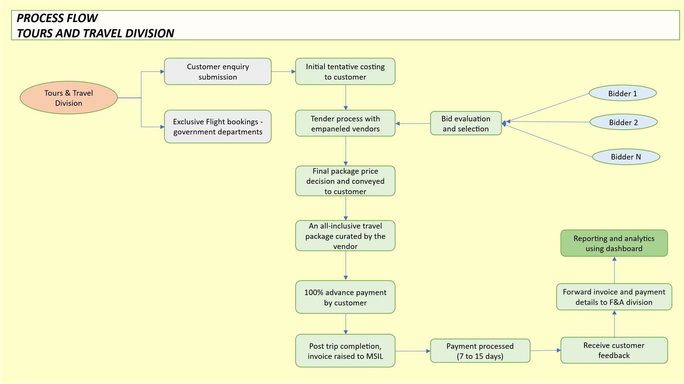

Paper
For over 5 decades MSIL has been successful in fulfilling the perennial demand of the students for quality notebooks at affordable price with its well-known brands of “VIDYA” & “LEKHAK”. Apart from the student notebooks, drawing and graph books, Paper Division has a full range of school and office stationery including computer stationery, security printed certificates etc. Company is operating through 6 Branches and 8 Depot located across the State (Bangalore, Mysore, Davangere, Hassan, Hubli, Mangalore, Gulbarga and Bijapur) for sale of Notebooks, School bags and Stationery items. “VIDYA” & “LEKHAK” Brand is even today a household name due to its time-tested quality, service and robust market presence.

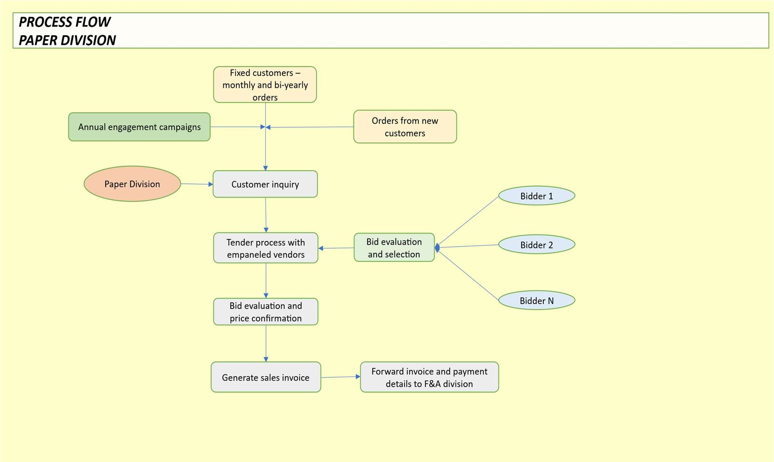

Consumer and Industrial Products Division
Consumer and Industrial Products Division deals with marketing of Solar Water Heaters and Solar Power packs under the brand name ‘Hot Spring’ & ‘MSIL Lights’. The aim is to encourage and facilitate the use of renewable source of energy. Solar Water Heaters and power packs are supplied in both domestic and non-domestic segments. Solar products have gained huge acceptance in the market as cost effective, low maintenance, and pollution-free alternative.

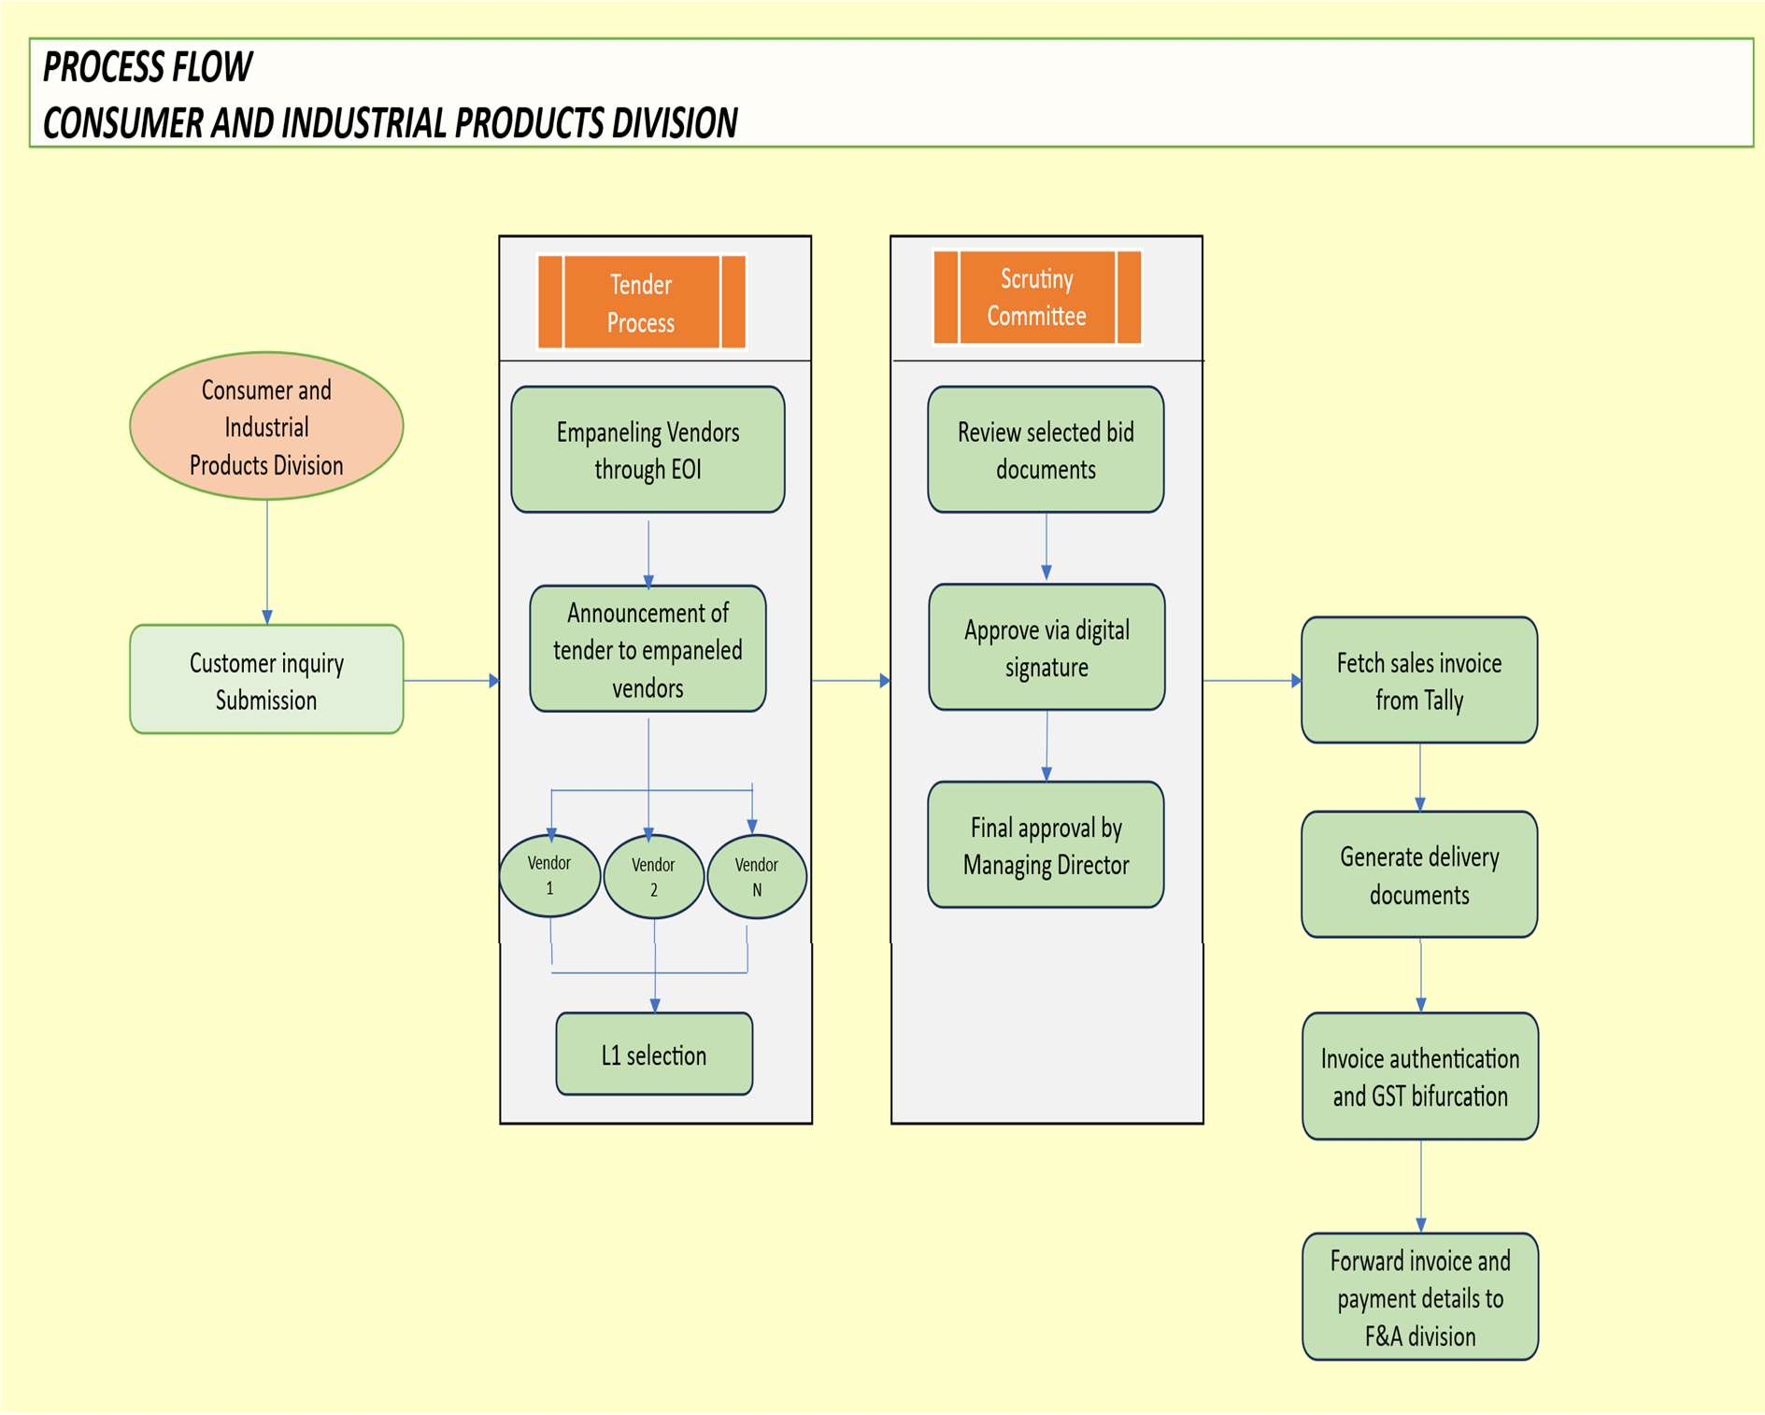

Pharma
Underscoring once again its commitment to common man, MSIL ventured into pharmaceutical sector in 2015. In order to make quality medicines available for all, particularly the poor and underprivileged, Govt. of India has initiated ‘Jan Aushadhi’ scheme by opening ‘Jan Aushadhi medical stores’ all across the country for selling generic drugs. The objective of the Government is to ensure ‘availability of quality medicine at affordable price’ since branded drugs are too expensive for the poor to afford.
Govt. of Karnataka has entrusted the task of opening Jan Aushadhi stores at Taluka and District Govt. Hospitals to MSIL. The department of Health and Family welfare is acting as Nodal department and as of now, Jan Aushadhi stores operating at various hospital premises.

Beverages
MSIL has an impeccable track record in executing various assignments entrusted by the Govt. of Karnataka with great success. One such latest assignment is ‘retail liquor’ business. Consequent to the ban on the sale of arrack in the state of Karnataka, instances of the sale of illicit liquor were reported in rural and remote areas, endangering the lives of people. Also, as the availability of liquor was largely limited to urban and semi-urban areas, illegal sale of liquor at inflated rates was on rise in the interior pockets of the state.

In this backdrop, in order to curb these malpractices, after assessing the demand, Govt. of Karnataka had initially allotted 463 retail liquor outlets to MSIL in the year 2009 followed by 900 outlets in the year 2016.

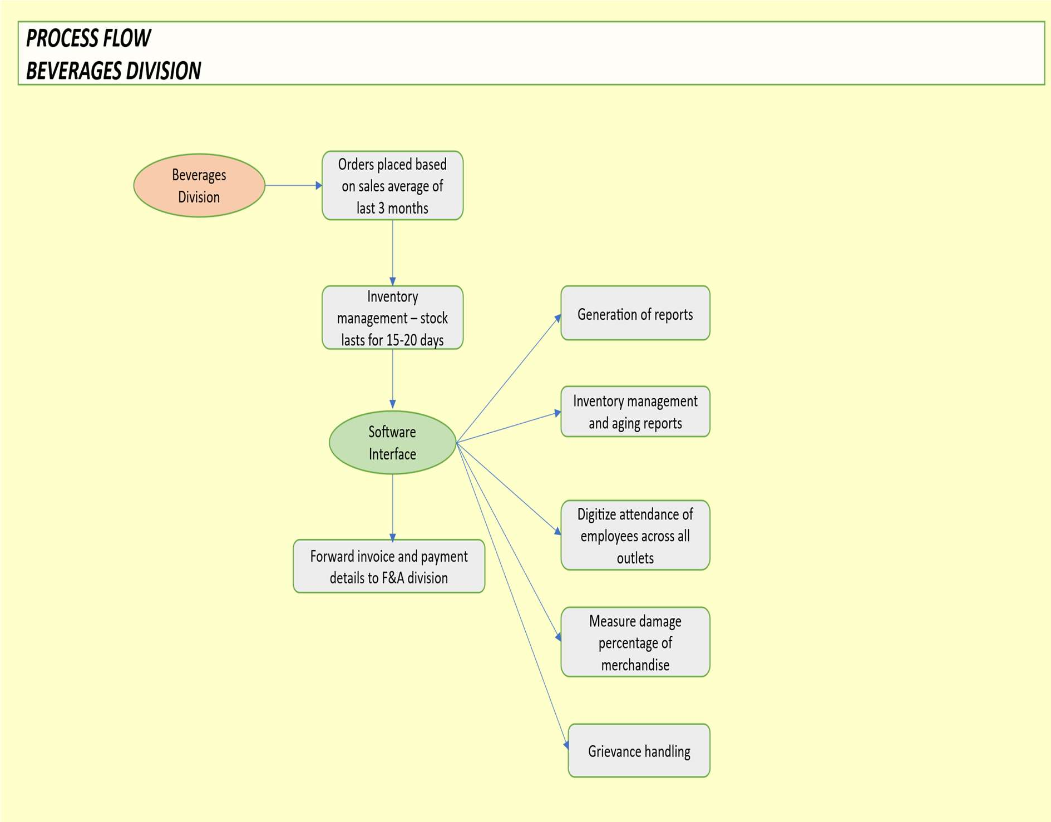

Chit Fund
The Chit Funds Division of Mysore Sales International Ltd. (MSIL) is a trusted financial service provider offering secure and regulated chit fund schemes. Established as part of MSIL’s diversified business operations, this division aims to provide a reliable and transparent avenue for individuals and businesses to manage their savings and financial investments.
With a commitment to ethical financial practices and customer-centric services, MSIL Chit Funds facilitates systematic savings and credit solutions through well-structured chit groups. These schemes empower participants with financial flexibility, allowing them to access funds when needed while fostering disciplined savings habits.
Being a government-backed organization, MSIL ensures complete transparency, security, and regulatory compliance in all its chit fund operations, making it a preferred choice for investors seeking credibility and stability. Through its well-managed financial offerings, MSIL Chit Funds Division continues to serve the diverse financial needs of individuals and enterprises across Karnataka

Verticals across Departments
The processes of the following divisions of MSIL will be part of the ERP Solution.
- Marketing, Sales and Distribution
- Inventory (Stores)
- Finance and Accounting
- Assets Management
- Supply chain management
- Management MIS

Sl.  No. | Departments | Vertical | No. of User(s)
1 | Paper (covering 6 depots) | - Marketing, Sales and Distribution  - Inventory (Stores)  - Finance and Accounting | 11
2 | Industrial Product Division | - Marketing, Sales and Distribution  - Inventory (Stores)  - Finance and Accounting | 5
3 | Tour and Travels | - Marketing, Sales and Distribution  - Finance and Accounting | 5
4 | Beverage (for 1000 outlets,  covering 6 zonal heads) | - Marketing, Sales and Distribution  - Inventory (Stores)  - Finance and Accounting  - Supply chain management | 1100

Project Detailed Scope:

The detailed scope of work for the project
The agency shall be responsible for delivering end-to-end ERP implementation services, encompassing the following key components.
- Agency shall conduct a detailed module-wise study to capture MSIL’s functional and technical requirements.
- Tailor the selected COTS ERP solution to align with MSIL’s specific business needs

- Oversee all phases of implementation with structured project governance and execution oversight.
- Evaluate MSIL’s requirements to determine appropriate hardware specifications, followed by installation and commissioning of the ERP platform
- Transition key datasets—including materials, products, and employee records— from legacy systems into the new ERP environment
- Deliver structured training programs and change management support to ensure effective system adoption across the organization.
- Provide ongoing support and maintenance for the ERP application for a period of three years post go-live to ensure system stability and user satisfaction.
- A dedicated Program Manager will be assigned for a period of one year to support project execution and strengthen MSIL’s internal ERP capabilities, enabling continuous improvement.

The scope of work for implementation
The scope of ERP implementation for MSIL shall be holistically defined by integrating the following strategic and operational dimensions:
- Detailed requirement gathering division wise and defining work flow process.
- Alignment with applicable statutory frameworks and best practices governing public sector enterprises in India.
- Incorporation of industry-recognized practices and operational models specific to manufacturing environments.
- Inclusion of functional and technical features to meet MSIL’s digitization and performance objectives.
- Mapping the ERP system to all operational departments to ensure enterprise-wide integration.
- Configuration of the solution to reflect MSIL’s existing process flows and service logic.
- Identification and enablement of key user profiles across MSIL to support secure and efficient system interaction.
- Seamless interfacing of the ERP solution with MSIL’s current applications and legacy infrastructure.
- Adoption of a structured approach to roll-out, encompassing defined phases, execution methodology, and compliance with implementation benchmarks.

The overview of the implementation services
The implementation agency will be responsible for delivering the following comprehensive services under the ERP deployment initiative for MSIL:

Solution design and deployment
      - Develop a business blueprint grounded in an assessment of MSIL’s operational workflows and existing IT landscape
      - Configure and customize the ERP solution to meet business requirements
      - Migrate operational data and functional information into the ERP environment
      - Import historical, contractual, financial, and employee-related data into the ERP system
      - Define and execute the cut-over strategy to ensure go-live readiness
      - Enable integration with relevant third-party or legacy systems, if required

Project Management
      - Align with MSIL’s objective to complete implementation and deployment within six months of contract signing
      - Mobilize a qualified team with expertise in ERP and relevant functional domains
      - Schedule and coordinate implementation activities to cover all functional areas within the stipulated timeline
      - Ensure resource deployment aligns with the planned implementation roadmap
      - Establish a structured framework for progress tracking, periodic reviews, and risk mitigation

Quality assurance
      - Engage specialists with in-depth knowledge in production, materials management, finance and accounting, and ERP modules to oversee quality and provide expert guidance
      - Adopt standardized templates and acceptance protocols for deliverables
      - Utilize native tools such as a solution manager for managing the project repository and work streams

Training and documentation
      - Conduct comprehensive user training across MSIL departments
      - Prepare detailed user manuals and training guides
      - Document business processes as configured in the ERP solution
      - Train key executives in performance monitoring and effective report utilization
      - Provide core team training on specific ERP development components

Post implementation support
      - Facilitate smooth user adoption of the ERP system
      - Enable process enhancements and report refinements based on operational feedback
      - Provide a helpline number for assistance.
      - Establish governance structures for SLA management and strategic oversight

Technical enablement
      - Assess hardware sizing based on solution configuration and performance needs, and recommend suitable specifications in the technical proposal
      - Assist MSIL with hardware installation and ERP system commissioning at the head quarters

The Overview of the support Services
- Provide helpline number for usage-related queries and minor technical issues
- Onsite technical assistance - Deliver hands-on user support during onboarding and critical operations, conduct database recovery and data synchronization in case of system crashes, perform performance tuning, bug resolution, and updates for essential functions.
- Post implementation Operational Support – Offer on-site assistance to ensure smooth operations after ERP deployment.
- OEM coordination and services – Ensure access to OEM-level ERP services including performance optimization, version upgrades, and system health checks.
- Documentation and updates - Maintain and enhance the documentation framework to reflect system upgrades, provide updated technical and functional manuals in line with new releases and enhancements.

Skill augmentation
- The Agency shall deploy a dedicated Program Manager for a period of one year to support the end-to-end execution of the project. Responsibilities will include driving project timelines, facilitating cross-functional collaboration, managing risks and dependencies, and ensuring timely reporting.
- This individual will serve as the central point of coordination across all work streams, ensuring alignment between business objectives, technical deliverables, and stakeholder expectations.
- The Program Manager will also play a key role in maintaining governance standards, tracking KPIs, and enabling smooth communication between internal teams

ERP Deployment Strategy:
The Agency shall adopt and deploy a comprehensive methodology for ERP solution implementation at MSIL, designed to fully achieve the project’s objectives and unlock the solution’s full potential—aligned with industry best practices. This implementation strategy should facilitate streamlined execution and expedited outcomes for all stakeholders. The methodology will centre around the following components:
- Execution of ERP solution implementation activities
- Provision of post-implementation support services
- Defined implementation approach and methodology

- Structured project planning and governance framework

Implementation activities:
    - The ERP implementation methodology shall be well-structured and aligned with globally recognized best practices. It will encompass the following key phases:
      - Project initiation and Preparation
      - Business Process study and System Design
      - ERP Solution Configuration and Customization
      - System Integration, Testing & User Acceptance
      - Data Migration and Validation
      - End-User and Technical training
      - Cutover Planning and Deployment to make the ERP solution fully operational
      - Post implementation support and Stabilization

Documentation Phase:
    - This phase will focus on establishing a clear project charter, defining communication and interfacing mechanisms, conducting initial training, and formulating a detailed action plan for immediate execution. It will also involve familiarisation of the System Integrator (SI) team with MSIL’s operational environment.
    - Business design and blueprint: The System Integrator (SI) shall develop a comprehensive Business Design or Blueprint, which will serve as the foundational reference document for all subsequent ERP implementation activities. This blueprint shall encompass the detailed design of all business processes and solution capabilities outlined in the RFP, covering the relevant organisational units. The blueprint formulation will involve:
      - In-depth system study and to identify key business processes
      - Consensus-building on process characteristics and process design formulation
      - Documentation of MSIL’s current operations and business flows
      - Definition and analysis of AS-IS and TO-BE processes
      - Gap assessment in relation to ERP best practices
    - Only the Business Blueprint formally approved by MSIL and endorsed by the ERP solution provider shall be considered final and implemented. Standardised templates shall be used throughout this phase to ensure consistency and completeness. Key deliverables of the Business Design phase:
      - Master process list across all relevant functions
      - User roles, associated activities, and access rights
      - Reporting requirements and format specifications
      - Interface identification, integration needs, and integration schemes

      - Data input formats and requirements
      - Output definitions and required formats
      - Training needs and change management planning
      - Hardware sizing and infrastructure considerations
      - Best practices and recommended process adaptations
      - Customization needs to meet statutory and organization-specific requirements
Implementation Commitments by the Agency:

Deployment Phase:
Based on the finalized functional design, the Agency shall be responsible for executing the following activities:
    - Realization: The Agency will perform system configuration and necessary customization in alignment with the approved Business Design or Blueprint. Key responsibilities include:
- Identification of processes for configuration and customization
- Execution of trial runs using MSIL data and demonstration of workflows to the MSIL user groups
- Addressing gaps by reconfiguring the system if outcomes do not meet expectations of MSIL management or end users
- User mapping: defining user roles, activities, and access authorizations
- Additional tasks will cover:
- Cross-module integration of detailed designs
- Configuration testing across modules
- Field identification for Master data and mapping with legacy systems
    - Configuration: To ensure cost-efficiency and seamless upgradeability, MSIL expects maximum utilization of standard ERP features. The Agency shall:
- Make essential configuration entries to meet business needs
- Apply small routines via User Exits and screen variants
- Configure field-level attributes (e.g., mandatory, hidden, display-only) as per business requirements
    - Customization: While MSIL aims to adopt standard ERP functionalities and leading practices, the Agency shall:
a) Undertake customization only where required to support specific, improved, or non-standard business processes documented in the Blueprint phase.

    - Development: If deemed necessary, the Agency may develop minimal custom applications on the same platform as the proposed ERP solution. All such developments:
- Must remain within scoped requirements
- Will be fully owned by MSIL
    - Functional Gap Resolution Protocol: If the Agency recommends development-based customization to resolve functionality gaps:
- MSIL reserves the right to engage external experts for validation
- If it is determined that the gap can be addressed through standard configuration, development shall not be pursued
- Costs incurred due to incorrect recommendations will be adjusted against the Agency’s progressive payments

Testing and Acceptance Phase:
    - A comprehensive test plan shall be developed by the Agency and formally approved by MSIL including their vendors and retail outlet attendees prior to execution. Test data, covering multiple user-defined scenarios and use cases, will be prepared in close coordination with users of MSIL. Pre-commissioning tests will be conducted to evaluate:
      - Compliance with defined functional requirements,
      - System performance, including response times and accuracy
      - Ease of use and overall user experience
      - Simultaneously, accompanying documentation will be reviewed by MSIL users to verify its completeness, clarity, and correctness
    - System Testing Protocol: Following the development and configuration/customization of the ERP Solution, the Agency shall formulate comprehensive procedures outlining the methodology for conducting System Tests. These procedures must be reviewed and approved by MSIL.
    - Upon finalization, the Agency will execute system-level tests to validate that the solution conforms to all functional and technical specifications as defined in the RFP. The testing shall adhere strictly to the workflows and standards established in the approved To-Be Process documentation.
    - Testing Outcomes and Acceptance Procedures: Based on the outcomes of all testing phases, the Agency shall prepare and submit a detailed report for MSIL’s review and formal approval. Test results, including system response times and performance metrics, must be demonstrated during System, Integration, and Stress/Load testing conducted at head office, within an environment/infrastructure mutually agreed upon by both parties. The Agency shall be responsible for the following:
- Test Plan Development:
      - Creating a comprehensive plan supporting Functional Testing and System/Integration Testing
b. Ensuring testing coverage is exhaustive, traceable, and auditable

c. Preparing test cases for User Acceptance Testing (UAT)
- System Integration Testing:
- Executing tests across the newly developed ERP system
- Validating data conversion and migration processes
- Ensuring proper integration and data flow between functional modules
- Acceptance testing procedures:
- Establishing validation steps to verify response times, software stability post-installation, and operational accuracy
- Including fine-tuning, installation of dependent components, and necessary debugging activities

Rollout Phase:
    - Data Migration Approach: The responsibility for migrating data into the new ERP system lies with the Agency. MSIL, in collaboration with the Agency, will jointly determine the specific datasets to be migrated. MSIL shall be responsible for collecting and providing the required data in a digitized format, structured according to templates and guidelines shared by the Agency. During the initial phase of the project, the system implementer is expected to deliver a comprehensive Data Migration Plan encompassing:
- Scope of the data to be migrated
- Upload templates and migration tools
- Timelines for data collection, digitization, and transfer
    - Key Activities under Data Migration will include:
- Development of data upload/download utilities
- Provision of migration templates and tools to MSIL
- Population and transfer of legacy, raw, and new data into the ERP system
- Training and facilitation of the MSIL core team for migration-related tasks
- Assistance in verifying data quality, completeness, and integrity
- Execution of integration tests using migrated master and transactional data
- Support to MSIL in establishing and managing Master Data protocols
    - Scope of Data Migration: The following categories of data are to be migrated into the ERP system as part of the implementation process
- Transactional Data - All open transactions, along with all transactions recorded from the beginning of the financial year marking the “Usage Ready” state
- Master or Standing Data - Includes vendors/suppliers, customers, employees, materials, work breakdown structures, equipment, specifications, cost data, and other core reference entities

- Live Project Data - All transactional records associated with active projects, to be captured and migrated in alignment with the approved TO-BE process definitions
- Associated Master Data - This comprises relevant drawings, test results, and other supporting documentation linked to the master data as applicable
The Agency shall be fully accountable for ensuring the completeness and accuracy of the data migration process. This includes adhering to the agreed timelines and ensuring all necessary data is transferred in line with implementation requirements.
    - Source Systems and Data Entry Responsibilities: The majority of data migration will be sourced from MSIL’s existing financial management systems and inventory with additional input from HR and administration systems as needed. In cases where data must be captured from physical records, MSIL will oversee the data collection process and execute the necessary data entry tasks in alignment with the migration plan.
    - End-User Training Strategy: The objective of end-user training is to equip users with the necessary skills and knowledge to effectively perform their designated roles at the “Usage Ready” stage of ERP deployment. Training modules will be tailored based on the specific functions and responsibilities of each user group. Accordingly, distinct user profiles will be defined to enable role-based training delivery.
    - Cut Over Strategy Framework: The Agency shall develop and document a comprehensive Cutover Strategy to support a seamless transition to the new ERP environment. This strategy must include
- A structured approach for initial data take-on
- Defined sequencing for subsequent data uploads and transitions
- Establishment of a support helpdesk along with detailed operational procedures
- Measures to minimize business disruptions and operational risks during cutover activities
This plan should ensure a controlled and auditable migration process, facilitating a smooth shift to the “Usage Ready” state.

User Acceptance and Go live Phase
    - To validate the ERP system’s preparedness for the “Usage Ready” state, the Agency shall undertake the following key activities:
      - Assist in establishing a helpline number to address user queries and support needs
      - Monitor system health, usage patterns, and performance metrics until the solution stabilizes
      - Ensure resolution and comprehensive documentation of all issues encountered during implementation
      - Execute final rounds of configuration, integration, and conduct volume

and stress testing
      - Initiate switchover to the production environment, marking the formal transition to live operations
    - Declaration of “usage ready” Status: The ERP system shall be formally declared “Usage Ready” upon satisfactory completion of the following activities
      - Acceptance testing - Successful execution and validation of system functionalities against defined requirements
      - Hardware commissioning - Deployment and operational readiness of all necessary infrastructure components
      - Data migration - Accurate and complete transfer of legacy data into the new system environment
      - Training - Comprehensive user training sessions to ensure smooth adoption and operational proficiency
      - User Setup and role mapping - Creation of user and assignment of roles/responsibilities aligned with access control policies
      - Establishment of a functional helpline number to assist users during the transition phase
    - Acceptance Criteria for “Complete deployment”: The ERP system shall be deemed "completely deployed" upon meeting either of the following conditions—whichever occurs later
    - User Adoption Support: Between the "usage ready" stage and the formal declaration of "complete deployment," the Agency shall extend user adoption support by deputing both technical and functional consultants at the client site. During this period, the Agency shall undertake the following activities:
      - Provide hands-on assistance to users in executing their daily tasks using the ERP system
      - Promote consistent and effective usage of the ERP system across relevant operations
      - Deliver targeted training to individual users on specific processes and activities aligned with their roles

High-level functional requirements -Departments:

Tours & Travel
High level functional requirements
Current mechanism | i. Customers enquire about travel packages via mobile number or e-mail. Upon receiving an inquiry, the concerned department will collect basic user info and provide costing for pre-planned packages and an approximate price estimate for  customized packages.
ii. MSIL will then float a tender on the e-procurement website which has empaneled vendors to obtain final quotations. The vendor offering the lowest price (L1) will be selected. After MSIL confirms the final package amount with the user, the user can make a booking by paying an advance (amount
varies by package).

High level functional requirements
iii. MSIL will issue a work order to the L1 vendor highlighting all the services to be included for the trip. The final payment must be made before travel. After the user reaches the destination, the selected vendor will manage the user's travel
experience until their return.
iv. Post trip completion, the vendor will generate an invoice to MSIL, and MSIL will process the payment between 7 to 15
days.
 | v. User feedback will be collected in the form of ratings & reviews and information about upcoming tour packages will be sent regularly to the existing customer base.
 | vi. Additionally, online flight bookings on credit basis for government organizations exclusively is handled by the concerned department. Currently personal log in IDs for various airlines are available.
ERP Solution | - Simple interface for users to submit inquiries via mobile  / e-mail: Users will have access to an easy-to-use platform that allows them to submit inquiries seamlessly via mobile number or email. This ensures convenience and accessibility, enabling customers to request information or assistance without technical barriers. The interface will be designed for efficiency, with predefined fields for essential details, reducing response time.
 | - Approximate package cost before vendor co-ordination: MSIL should be able to generate an estimated package cost using a predefined pricing algorithm before initiating vendor coordination. This helps potential customers get an idea of expenses early in the planning process, improving transparency and aiding decision-making.
 | - Vendor portal for Tender Process and Selection: A dedicated vendor portal will streamline the tendering process, allowing MSIL to float tenders on the e-proc website. Vendors can submit bids, and the system will help identify the lowest bid (L1 vendor) based on predefined selection criteria, ensuring a fair and competitive procurement process.
 | - Backend interface for Price Comparison: MSIL will have an intuitive backend interface that enables efficient comparison of vendor quotations and pricing. This system will facilitate informed decision-making by providing automated sorting, filtering, and analytical tools to assess price variations among different vendors.
- Final Package Price Confirmation Post Vendor Selection: Once a vendor is selected, the system will confirm the final package price based on the agreed terms and conditions. The
transparency of this step ensures both MSIL and its

High level functional requirements
customers receive accurate financial details before proceeding with bookings.
- Booking and variable advance payment options: The ERP system will support flexible payment structures, allowing customers to make bookings and advance payments based on their preferences. Options for full payment, installment-based advances, or variable deposit amounts will be available, catering to different financial needs.
- Flight booking integration with Prepaid Airlines Accounts: MSIL's prepaid airline accounts will be integrated into the system, allowing flight bookings on a credit basis with a repayment window which has a defined time period. This feature provides financial flexibility while streamlining travel arrangements for customers.
- End-to-end vendor handling support: The system will oversee complete vendor coordination from the initial destination to the final return stage. This ensures that all logistical aspects, including accommodation, transport, and additional services, are efficiently managed without delays or discrepancies.
- User feedback mechanism: A built-in feedback system will enable users to share their experience with MSIL's services. Ratings, reviews, and structured survey responses will be collected and analyzed to improve service quality, vendor selection, and overall customer satisfaction.
- Dashboard: The dashboard will serve as a comprehensive, real-time analytics tool to monitor key performance indicators (KPIs) and trends, enabling data-driven decision-making. It will feature an intuitive layout with interactive visualizations, ensuring stakeholders can easily interpret and act on the data. Key Components and Metrics:
  - Bookings Trends
  - Revenue from Tours
  - Customer Satisfaction Analysis
  - Top Locations

Industrial Products Division

High level functional requirements
i. Customer sends inquiry about solar water heaters or solar
power packs marketed under the name of ‘Hot Springs’ and ‘MSIL Lights’ respectively.
ii. An EOI is floated on Karnataka Procurement Portal to
empanel vendors for a duration of one or two years.

High level functional requirements
 | iii. A restricted rate tender is floated for each customer enquiry to the empaneled vendors.
Current Mechanism | iv. Documents from bidders are submitted in the KPPP website as per tender criteria
 | v. Scrutiny committee convenes to verify and sign physical annexures
 | vi. Final file is forwarded to the Managing Director
 | vii. Upon approval, agreement is signed with the L1 bidder
ERP Solution | Committee-Based Document Verification  - Secure login for scrutiny committee members  - Digital bid document to be viewed on the ERP with approval workflow  - E-signature provision mapped to each member and  forwarded to Managing Director
Tally Integration & Document Generation
- Fetch sales invoices from Tally upon generation
- Auto-generate Delivery Challan, E-way Bill, Installation & Commissioning Certificate
- Predefined templates of the above documents to be
stored in the application
Installation Documentation
- Technical consultants to upload pre-dispatch and post-dispatch site visit documents to be incorporated as part of the application
- Document and photo upload support
Supplier E-Invoice Handling
- Software to allow uploading of supplier invoices
- Unique ID to respective order using PO number
GST Bifurcation & Billing Logic
- Bifurcation logic based on entity type (Govt. vs Private); no GST to be added to orders from Government departments
- Automated GST computation & ITR-ready billing export to HO
- Final bills to follow standard invoicing format
Invoice Authentication
- Verification module for validating invoice integrity and GST calculation
- Role-based access to audit and authorize deductions
HSN Code Integration
- Uploadable HSN database linked with product master
- Auto-suggest dropdown based on product name search
- Mandatory selection before invoice generation
Inventory Management
- Live inventory table with color-coded alerts for negative balances
- FIFO/LIFO support depending on department
preference
 | Aging Report from Tally

High level functional requirements
- Pull receivable/payable aging data directly from Tally
- Display alongside transaction history for reference
Supplier Transaction Balance
- Dashboard view for supplier-wise order summary
- Highlight payment status, balance due, and cumulative transaction value

Paper Division
High level functional requirements
Current Mechanism | - Products sold: Notebooks (various sizes), stationery, blank marks card
- Orders from regular customers (monthly/half-yearly) and proposals to new customers
- New vendors may proactively acquire new customers
 | - Tender is floated to empanelled vendors through KPPP, L1 bidder selected and approved by MSIL and order placed upon price acceptance
 | - Inventory managed via Vallabh’s internal interface, Manual BRS operations; limited automation, Invoices generated using a predefined format
 | - Lekhak contest held annually for brand engagement
ERP Solution | - Product and Inventory Management:  - Product Catalogue Structure  - Notebooks (varied sizes), school/office stationery, blank mark cards  - Product attributes: size, use case, material type  - Inventory Control  - Automated tracking with FIFO/LIFO logic  - Aging reports for optimal stock rotation  - Raw material allotment automated  - Stock Visibility  - Real-time dashboards for item availability and consumption  - Integration with procurement and sales module
- Order Management Workflow:
  - Customer Segmentation
    - Regular Customers: Monthly/Half-Yearly frequency
    - New Customers: Acquired via proposals or vendor outreach
  - Sales Order Process
    - Proposal submission → Approval → Sales Order Creation
    - Standard order templates used to auto-generate orders
  - System Alerts

High level functional requirements
- Pending customer response notifications
- Proposal validity tracking and expiry prompts
- Approval Workflow:
- Multi-level review before order confirmation
- Purchase Order Integration: Linked with inventory, order requirements, and supplier delivery timeline
- Finance and BRS automation
- Banking Retail System (BRS)
  - Auto-reconciliation with bank feeds
- Invoice Management
  - Configurable invoice templates (GST, discounts, terms)
  - Seamless ledger integration and digital dispatch
  - Digitization of vendor invoices for further payment processing
- Marketing and Promotion:
- Annual Engagement Campaigns
  - Lekhak contest managed within campaign module
  - Entry tracking, winner selection, and event scheduling
- Digital Marketing Integration
  - social media outreach for Vidya and Lekhak books
  - Generate insights
- Reporting and Analytics:
- Sales trend analysis by customer type or item category
- Product aging dashboards
- Vendor bid history & performance ratings

Beverage Division
High level functional requirements
Current mechanism | - Order Placement  - No tenders floated; MSIL functions as a distributor.  - Order quantities are determined using a predefined algorithm:  - Based on average sales of the last 3 months.  - Exceptions are holidays and special occasions.  - Orders are placed informally via WhatsApp.  - No formal indent or approval workflow exists
- Inventory Management
- Stock maintained for 15–20 days as per MSIL guidelines.

High level functional requirements
 | - Liquor bottle aging is tracked using the existing software
- Transportation
- Managed by a separate department.
- Quantity details shared via message/indent.
- Transportation is outside MSIL’s operational scope
- Software Usage
- Existing software in use since 2010; updated as and when needed
- Available reports include:
- Item-wise purchase and inventory reports.
- Outlet-specific ledger.
- Distillery report.
- Indent vs. purchase comparison.
- Sales target and TDS tracking.
- Damage percentage and insurance compensation logic
- Attendance Tracking
- Manual attendance maintained for retail outlet employees.
- Verified by HR and uploaded post-confirmation from District Liaisoning Officer (DLO).
- Identified as a major drawback due to inefficiencies
- Grievance Handling
- MRP violations and customer queries are tracked informally.
- No structured resolution mechanism in place
Identified gaps and challenges | - Order Placement: Informal communication via WhatsApp; lacks audit trail and structure.  - Attendance: Manual process; time-consuming and prone to manipulation.  - Sales Reporting: No daily summary upload; risk of malpractice.  - Grievance Redressal: No formal feedback mechanism; poor customer experience.  - Software Limitations: Legacy system lacks  automation and scalability
ERP Solution | - Demand Forecasting and Order Placement  - ERP auto-generates order recommendations based on:  - Previous sales data (last 3 months).  - Calendar-based exceptions (holidays, events).  - Formal indent raised within ERP.  - Approval workflow:  Branch Manager → Division Head → System-triggered  order placement
- Inventory and Stock Management
- Real-time inventory tracking with alerts for:
  - Stock below 15-day threshold.
  - Overstocking risks.
Liquor aging tracked via batch and barcode integration

High level functional requirements
- Sales Summary Upload
- Daily sales summary auto-generated by POS or outlet system.
- Mandatory upload to ERP by end-of-day.
- Dashboard access for DLO, Finance, and Audit teams
- Attendance Digitization
- Biometric or mobile-based attendance capture at outlets.
- Auto-sync to ERP with role-based verification.
- HR and DLO access for validation
- Grievance and Feedback Mechanism
- Customer complaints logged via:
  - Mobile app/web portal.
  - Retail outlet interface.
- Categorization: MRP violation, product quality, service feedback.
- Reporting and Analytics
Custom dashboards for:
- Sales trends and outlet performance.
- Indent vs. actual purchase.
- Damage percentage and insurance claims.
- Employee attendance and compliance.
- Grievance resolution status

NOTE: Based on the existing software MSIL is free to ask system integrator to develop required solutions for beverages Division only.

High level Functional Vertical Requirement:

Marketing, Sales & Distribution
High level functional requirements
Business Process | Marketing & Distribution
 | Module consisting of following Core Process,
 | Sales & Distribution
 | Sales Support
Customer, Partner support management.
- Manage all business support interactions in one system.
- All notes, calls, meetings and tasks to be easily accessed and reviewed.
- Drag and drop e-mail correspondence making it easy for archiving and retrieving communication
- Single, central database of information to eliminate the need to enter duplicate information, also promote information sharing among all departments
- Link and drill down to other ERP modules such as Bill of manufacturing, inventory
items, order, shipping, invoices, POs, BOL's, RMA's, Corrective
actions, PLM and more
General | Ability to receive & manage enquiries
System should have facility for material dispatch integrated with
warehouse module
 | Ability to incorporate billing module for invoice generation along with credit or debit memo generations.

High level functional requirements
 | Ability to generate graphical representation of yearly/ monthly sales report customer wise both for sales with in India and foreign trades
 | Module shall allow importing selected historical data for analysis and planning the production accordingly.
Billing | Facility to raise tax invoice against the material dispatched. Validate  & integrate with finance module
Ability to track payments received from regional offices on daily
/weekly and monthly basis. This shall be available to finance section for reconciling the accounts at the end of the month and shall
monitor the closing balance of each divisional offices.
Shipping | Ability to assign shipper against each shipment from the list of approved shippers by regional offices. Shall support shipping goods to  different address against a single sales order.
 | Ability to dispatch of materials tightly integrated with warehouse module to validate stock for partial or full shipment.
 | Ability to create Pick tickets for picking goods
 | Ability to create packing slips for dispatch of goods
 | Ability to issue Advanced Shipping Notices
Transportation | Facility to update and track goods received acknowledgement with the details like product and quantity received for further reference and records. ERP shall have option to upload these documents for  tracking.
 | Ability to select & choose particular vehicle type for transportation

Finance and Accounting
High level functional requirements
ERP Solution | Multi division Accounting Integration  - Maintain separate accounting modules for each subdivision with seamless linkage to the central F&A division.  - Enable real-time data synchronization between subdivision ledgers and the consolidated financial system.  - Support drill-down views from consolidated to individual  division-level transactions and balances.
Consolidated Invoice and Payment Management
- Capture and maintain a unified ledger of all invoices raised and payments received across sub-divisions.
- Enable automated reconciliation of payments against invoices, with exception handling and alerts.
- Provide audit trails for invoice lifecycle—from
generation to settlement.
Inventory and BRS automation
- Automate inventory valuation and financial postings linked to procurement and consumption.
- Implement BRS automation with rule-based matching of bank statements and ledger entries.
- Flag mismatches and generate reconciliation reports
with approval workflows
 | Debtors and Creditors Aging Analysis

High level functional requirements
- Generate aging reports for receivables and payables, with emphasis on items exceeding 90 days.
- Provide actionable dashboards for follow-up, escalation, and provisioning.
- Support classification by division, vendor/customer,
and aging buckets
Quarterly Balance Sheet Generation
- Automate generation of division-wise and consolidated balance sheets on a quarterly basis.
- Include configurable templates aligned with statutory formats and audit requirements.
- Support versioning, annotations, and export for
external audit and board review
Role Based Dashboard Access
Provide interactive dashboards for:
- Managing Director and Chief Financial Officer: consolidated financials, trends, and alerts.
- Division Heads: division-specific financial summaries and KPIs.
- Auditors: view-only access to financial statements,
audit logs, and compliance reports.
Scalable Plug-and-Play Architecture
- Support on boarding of new divisions with minimal configuration effort.
- Allow dynamic linking of new accounting modules to the central F&A system.
- Ensure consistent data structure, reporting formats,
and access controls across all divisions.

Inventory
High level functional requirements
Module consisting of following Core Process, | Goods are Delivered
 | Goods Reviewed, sorted & Stored
 | Inventory Level Monitoring
 | Stock Orders are placed
 | Order Approval
 | Payment Process
 | Low Stock Level Triggers Purchasing
General | Ability to manage raw material stocks
 | Ability to receive delivered raw materials
 | Ability to do quality check against specification
 | Ability to have graphical representation of the stores
Facility to perform quality check against the specification and record acceptance or rejection of
material
Ability to move the rejected/unused materials to
disposal module
 | Ability to analyze and compare the Special wood oil produced against the Special wood procured

High level functional requirements
Ability to create a detailed dashboard for HOD to get the stock details at any point in time for further
analysis and action.
Ability to carry out Where Used Analysis -With Mass
Substitution
 | Ability to carry out Manual & eKanBan
 | Ability to do Unlimited Cost Rollups
 | Ability to manage Consignment Inventory (VMI)
 | Ability to use Unit of Measures Conversions
 | Ability to use Average Cost Analysis
 | Ability to do Mass Pricing Updates
 | Ability to do Part Number Cross References -AKA
 | Ability to manage FIFO/LIFO Tracking
 | Ability to do Shelf Life Analysis
 | Ability to Separate inventory master records for each manufacturing individual location (or "EPlant")
Complete lot number tracking and traceability
including supporting documents
Ability to do Serialized inventory control along with
barcoding and labelling
Standard built-in Dashboards and reports specific to
inventory management
 | Ability to do supplier evaluation based on performance
Delivery of Goods | Ability to generate inward movement of materials at  the gate
Ability to create goods receipt at the stores before
quality check.
Goods Reviewed, sorted & Stored | Generate goods receipt note (GRN) for materials passed through quality check
Facility to sort the materials received as per the
category of the raw material received
Ability to assign a QR code for the batch supply to
further track the inventory
 | Ability to accept produced Special wood oil cans from Mysore divisions and store it in lockers with qty details
Stock orders placed | Ability to raise indent to procurement division for purchase of raw materials against the sales order
Inventory Level Monitoring/Low  Stock Level Triggers Purchasing | Ability to get instant alerts when the stock goes below  the threshold limit set
Order Approval | Ability to issue goods against approved orders
Payment Process | Ability to pay the supplier against the material received

Supply Chain Management
High level functional requirements
Business Process | Supply Chain Management
Module consisting of integration of following Core
Process,
 | Raw Materials
 | Suppliers
 | Production
 | Distribution
 | Retail

High level functional requirements
General | Ability to offer Wireless warehouse for in-coming, WIP and outgoing material/finished goods
 | Warehouse module should have built-in Barcoding and labelling platform - including QR coding
Multiple picking techniques to be supported –configurable interleaving, WAVE picking and planning, rules based directed picking including FIFO, FEFO,
LIFO
Slotting storage locations based on actual usage
history so fast moving products are more easily accessible
 | Ability to offer “Milk run” planning
 | Shelf life management - tracks expirations and automatically identifies non-conforming inventory
Ability to integrate and manage all the core module from purchase or materials to dispatch of materials to
branch offices and retail stores.
Ability to integrate with inventory, procurement,
production, warehousing modules to track the complete supply chain from end to end
Ability to provide an overview of the supply chain
management to analyze the issues and define actions to improve efficiency
Raw Materials | Ability to maintain complete specifications for  materials, the specifications for materials conveyed to procurement, and other sourcing functions
Suppliers | Ability to optimize inventory and external procurement of materials and services, determination of possible sources of supply, and monitoring of supply and  payment to vendors
Production | Ability to link with material requirement planning (MRP) in production, which determines the inbound  material required to complete a production order
Distribution/ Retail | Facility for order fulfillment, amount of material to be transported in the supply chain at each storage site  and shipping of the goods.

Assets Management

High level functional requirements
Module consisting of following Core Process, | Module consisting of following Core Process,
 | Fixed Assets
 | Asset Repository
 | Track Assets
 | Conditions & Performance
 | Forecast Maintenance
 | Annual Maintenance Plans
General | Ability to manage assets and maintenance of assets of the company
Ability to generate dashboard indicating the assets
available and maintenance schedules for those
Fixed Assets | Ability to record, maintain and update fixed assets of  the company

High level functional requirements
Track Assets | Ability to keep track of assets such as furniture’s/fixtures, machineries, equipment’s, land,  Special wood plantations and buildings
Asset Repository | - Ability to have centralized asset data repository for  all the assets.
Forecast Maintenance | Ability to forecast maintenance cost through planned  AMC’s
Integrate the maintenance plan with scheduling
platform automatically
Conditions & Performance | Facility to manage/record the maintenance of these assets by competent authority such as machineries & equipment’s by production in charge and buildings by  civil department.
Annual Maintenance Plans | Ability to automate tracking of maintenance of machineries and equipment’s with timely alerts to  extend and improve asset life and reliability
Ability to automate tracking of maintenance of
machineries and equipment’s with timely alerts to extend and improve asset life and reliability

MIS

ERP Module | 12. Management MIS
BI Platform - Should offer a 360 view of all operations and functions and provide advanced analytics. We want these to be used by all functions, roles, management and make it a way of life for our
Organization
 | Ability to offer drilldown functionality to view critical detail and offer 'any time - anywhere' availability with web-enabled facility
Dashboard should be accessed minimum by all the Users as required by Customer. Minimum no. is as per the User requirement and can be increased to more.
Please clarify the license cost for this
 | Ability to configure function-specific dashboard showing the key metrics to be measured
 | Dashboard to extra data from each module - and show it in chart, bar graph, pie chart
 | We will need multiple users to see these dashboards -please specify the licensing requirement clearly
We should be able to link other web-enabled dashboard in the same platform to get a unified
experience
 | Reports -
Offer built-in reports specific to each Function out-of-box, with option to configure them as required.
Readymade reports to eb offered for SCM, Accounts, Finance, SCM, Production, Maintenance, Quality and
Management
 | We should be able to add our logos, pictures, addresses and customise the reports
 | Alerts
 | Ability to create User defined alerts - including group alerts as per Dept/Function
 | Alerts should be configurable as per thresholds, frequency, time, event

Ability be send Alerts through SMS/email
Customer User fields & Self-configurable forms to be
available in all modules
Ability to capture relevant data in ERP and extract for
Dashboards
Ability to create and configure forms

Annexures to Functional Requirements
Annexure – A
Marketing, Sales & Distribution Module: Sub Modules & Flow Charts

Master Data
Transportation
Sales
Shipping
Sales Support
Billing

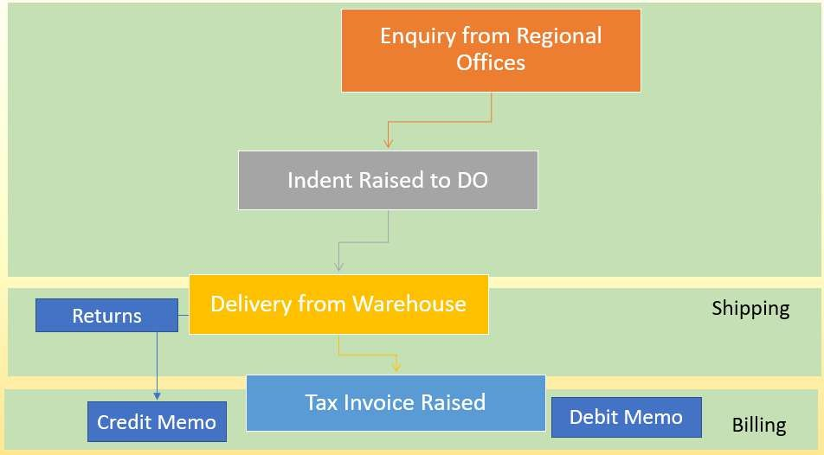
Shipping Docs
Pick n Pack
Inventory
Management
Delivery
Schedule
Stock
Transfer

Inventory - Functional Modules & Flow Chart Annexure - B


Goods are
Delivered
Order Approval
Low Stock Level
Triggers Purchasing
Goods
Reviewed, sorted & Stored
Stock Orders
are placed
Inventory Level
Monitoring
Payment
Process

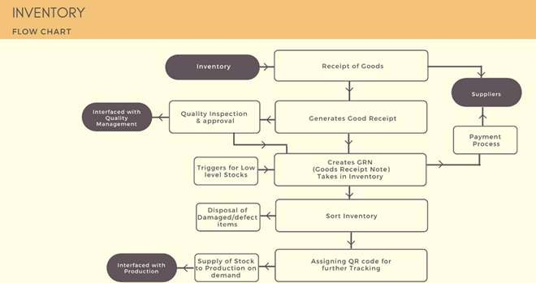

Finance & Accounting: Functional Modules and Flow Chart Annexure C

Funds
Management
Accounts
Receivables
Cost
Accounting
Audit
Accounts
Payable
General
Ledger
Fixed
Assets
Taxes

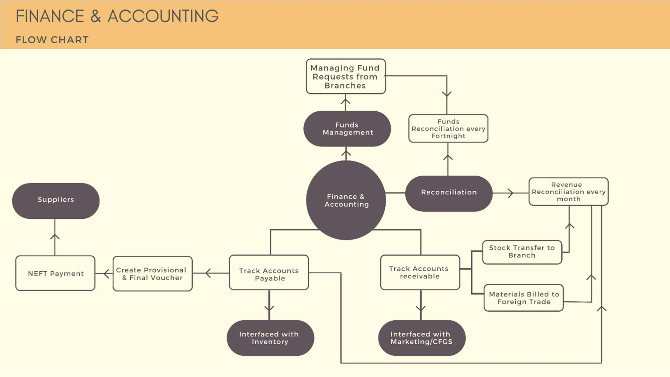

Asset Management - Modules & Flow Chart Annexure D
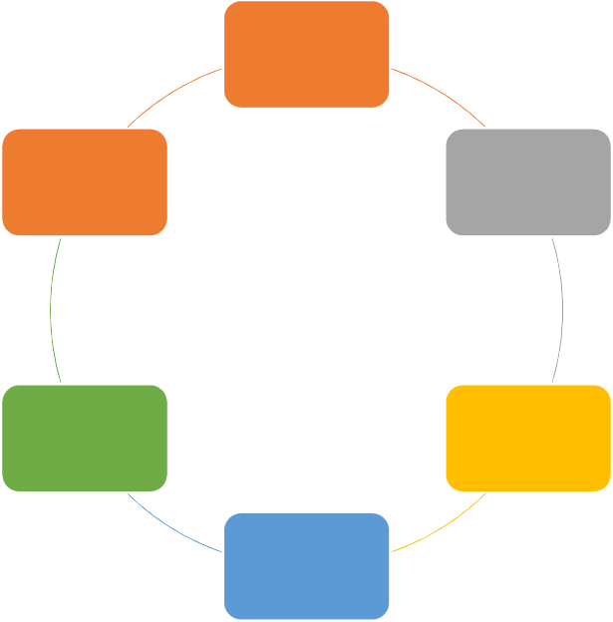
Fixed Assets
Annual
Maintenance Plans
Asset
Repository
Forecast
Maintenance
Track Assets
Conditions &
Performance

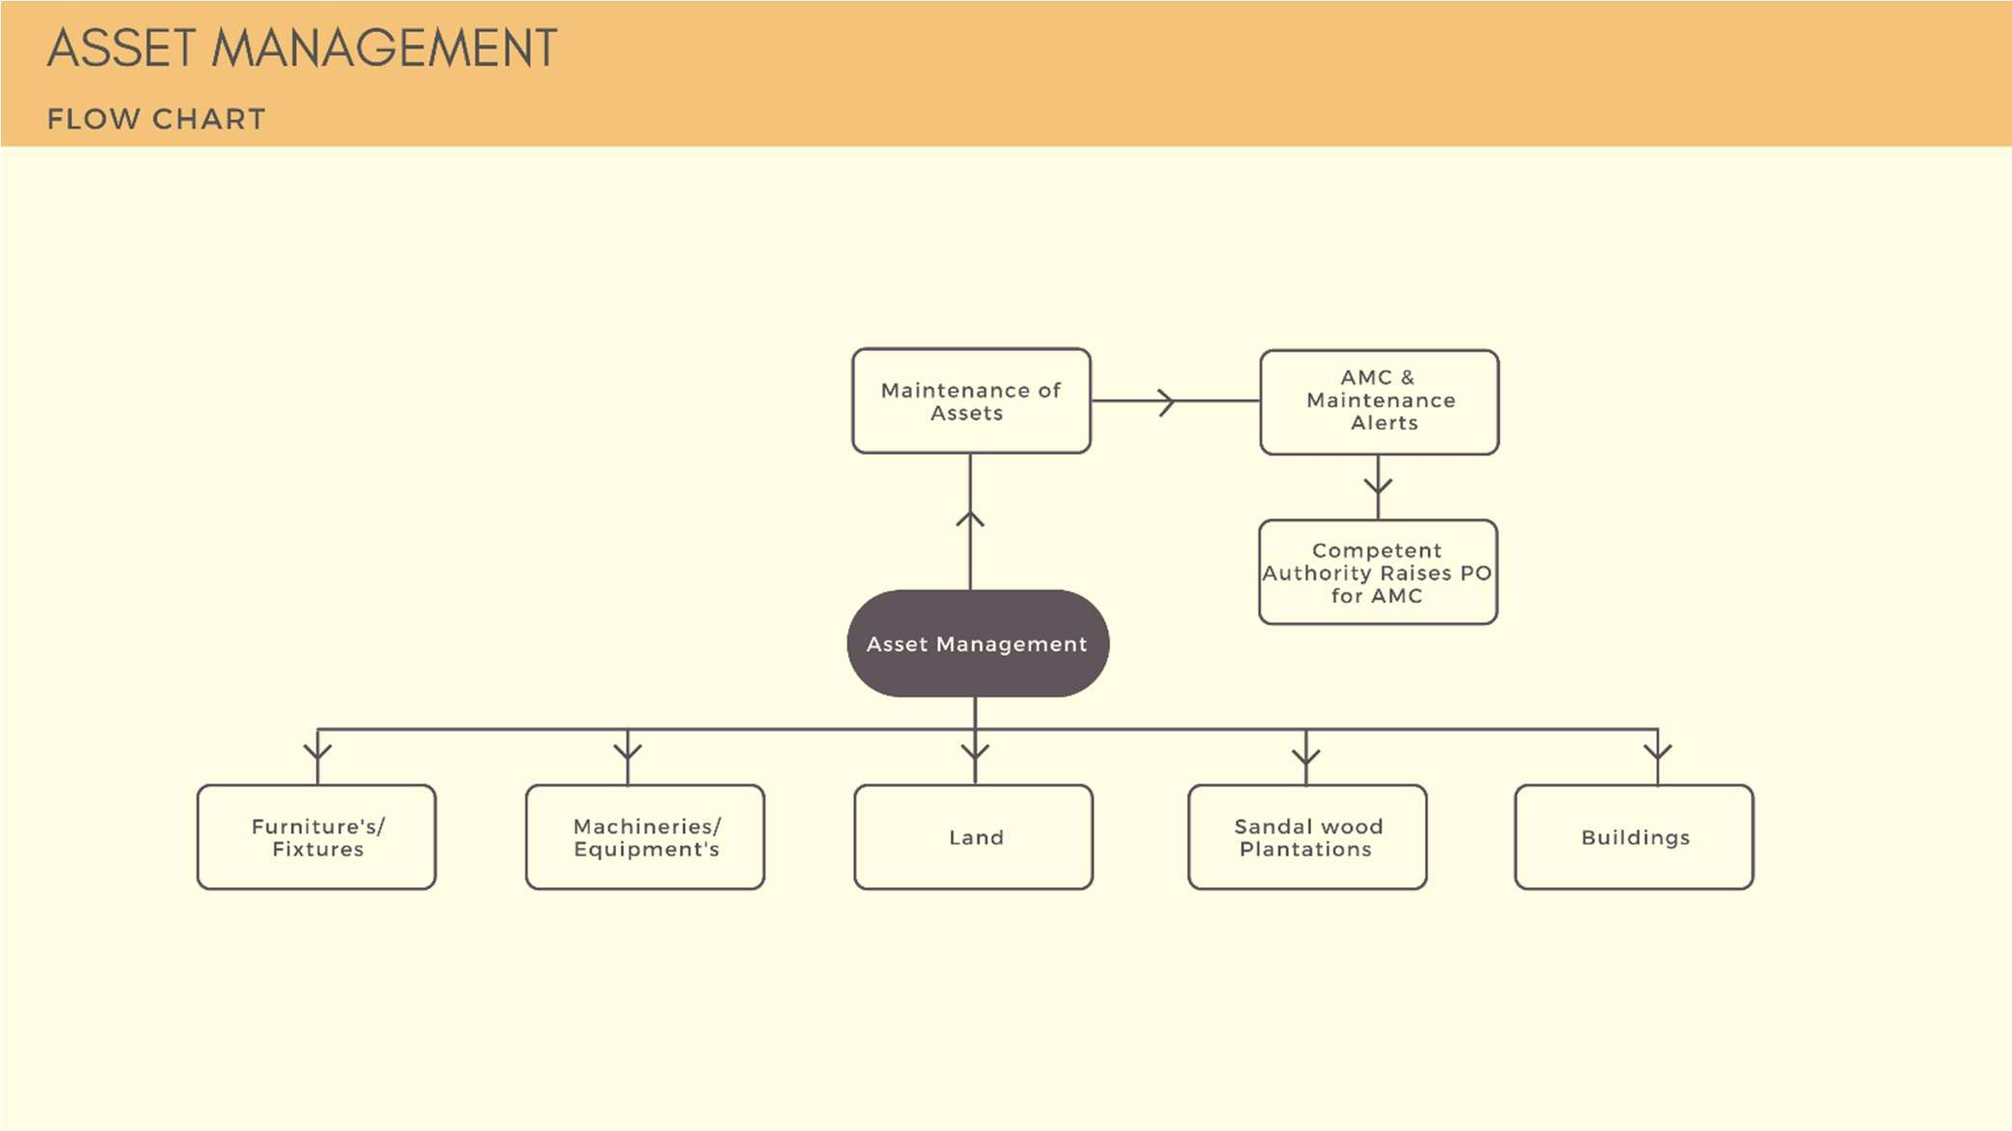

Supply Chain Management Functional Modules & Flow Chart Annexure E

Production
Suppliers
Distribution

Raw Materials
Branch
Location
Customer

